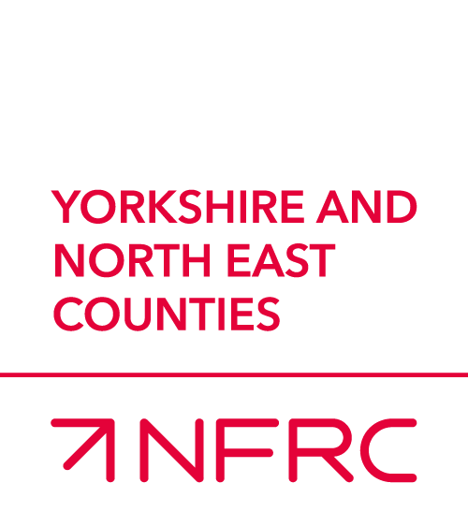

**AND MEMBERS DAY**

**REGIONAL AGM**

**25th JULY 2025 at Thirsk Racecourse**

**Thank you for expressing an interest to be our Main Sponsor at the 2025 members day. The Main Sponsor package includes the following;**

* You will enjoy a three-course meal and private bar in the upper pavilion overlooking the parade ring.
* Drinks package, Wine (2 red, 2 white, 10 bottled beers, still & sparkling water)
* Race Day Sponsorship – Name the Race, your guests can go down to the ring to choose the ‘best turned out horse’ and make the Trophy presentation
* Advertising – Presentation space for your banner/literature;
* Full page and front cover on NFRC Raceday brochure;
* Your advertisement banner in the parade ring
* Photo opportunities for your own PR Team
* Photos on NFRC website and Social media

The sponsorship package costs

**£4700 plus VAT**

**Martin Adwick -** [**martinadwick@nfrc.co.uk**](mailto:martinadwick@nfrc.co.uk) **or phone 7933 502 811**

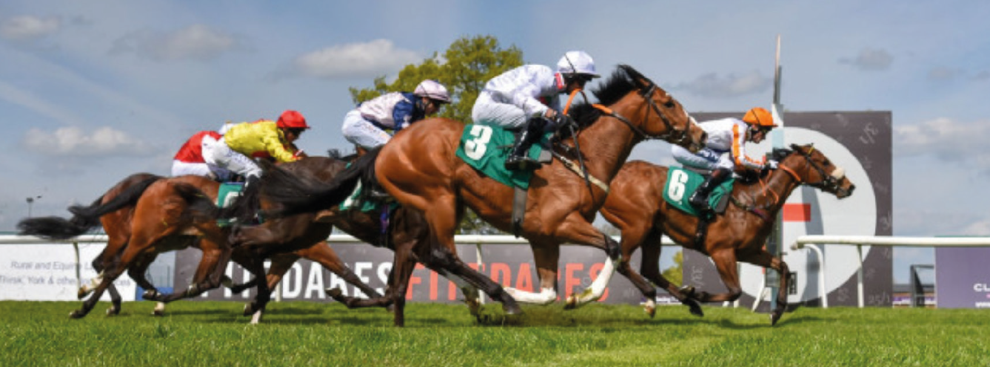

MRK188 v1.0 04/2022