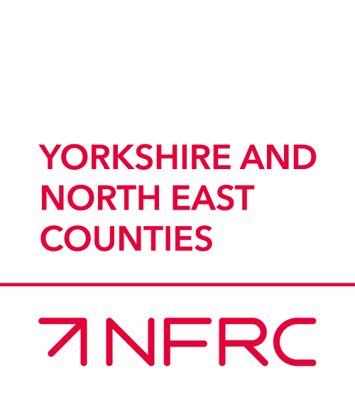
AND MEMBERS DAY
REGIONAL AGM

25th JULY 2025 at Thirsk Racecourse
Thank you for expressing an interest to be our Main Sponsor at the 2025 members day. The Main Sponsor package includes the following;
- You will enjoy a three-course meal and private bar in the upper pavilion overlooking the parade ring.
- Drinks package, Wine (2 red, 2 white, 10 bottled beers, still & sparkling water)
- Race Day Sponsorship – Name the Race, your guests can go down to the ring to choose the ‘best turned out horse’ and make the Trophy presentation
- Advertising – Presentation space for your banner/literature;
- Full page and front cover on NFRC Raceday brochure;
- Your advertisement banner in the parade ring
- Photo opportunities for your own PR Team
- Photos on NFRC website and Social media
The sponsorship package costs
£4700 plus VAT
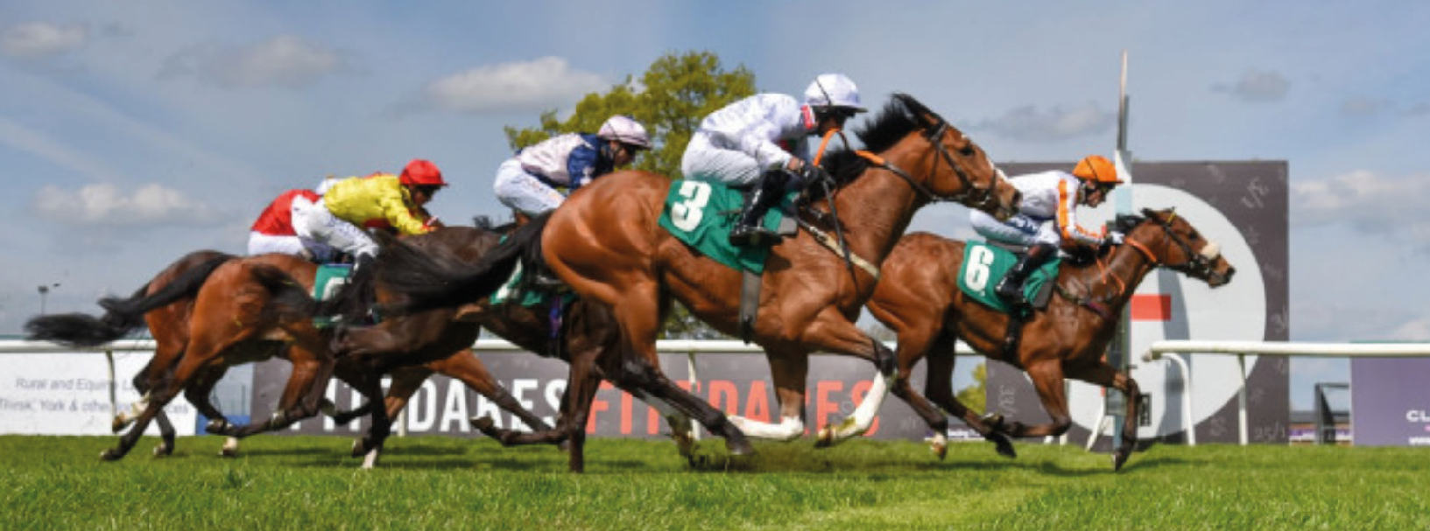
Martin Adwick - martinadwick@nfrc.co.uk or phone 7933 502 811
MRK188 v1.0 04/2022

