
NFRC
31 Worship Street, London, EC2A 2DY
www.nfrc.co.uk | 020 7638 7663 | helpdesk@nfrc.co.uk

Late payment consultation: tackling poor payment practices – Full Response National Federation of Roofing Contractors

- Name: Gray Gibson

- Email: graygibson@nfrc.co.uk

- Capacity: A representative body

- If you are responding on behalf of a representative body, make it clear who the organisation represents and, where applicable, how the members’ views were assembled:

NFRC (National Federation of Roofing Contractors) is the UK’s largest trade association for the roofing and cladding industry. We represent over 1,300 businesses across the supply chain, with the majority comprising micro and SME contractors, and the rest comprising large contractors, manufacturers and merchants. Our Members collectively employ or engage around 75,000 people nationwide and contribute £6 billion dollars to the UK economy.

NFRC has long advocated for reform of payment practices and retention clauses, providing ample opportunity for consultation and collation of Members perspectives on these issues. In 2023, we hosted a parliamentary reception on retentions, giving our Members the opportunity to engage directly with government and industry stakeholders. We have also carried out our own research into the issue: in 2021, we surveyed Members and estimated that £300 million of roofing and cladding subcontractors’ cash was held in retention at any one time. In 2023, 86% of Members surveyed reported difficulties recovering retention payments on local authority contracts. In 2025, 80% of responding contractor Members reported that retentions affect their business, with 19% reporting a significant impact, 36% a moderate impact, and 25% a minor impact. Through our quarterly State of the Roofing Industry surveys, we continue to gather regular data on payment terms, enabling us to track trends and sentiment across our sector.

In preparing this consultation response, NFRC has participated in a roundtable with DBT officials, major contractors, and specialist trade bodies hosted by Build UK. We also have hosted a webinar for our trade association Members where DBT officials presented the consultation’s key proposals; this session was recorded and made available to all Members and further feedback sought and implemented. These engagements, along with feedback gathered at in-person regional events and committee meetings (in all the devolved nations) over the past three months, have shaped NFRC’s position as an accurate reflection of our Members’ views. NFRC has also authored numerous thought pieces on the topic of retentions in roofing and cladding trade press outlets such as Roofing Today and Total Contractor. Throughout all engagements, NFRC has also encouraged and supported Members to respond in their own right.

- Size of business (if applicable)
As mentioned previously, NFRC (National Federation of Roofing Contractors) is the UK’s largest trade association for the roofing and cladding industry. Approximately 1,150 of our Members are contractors, while around 150 are supplier Members, including manufacturers, merchants, distributors, and other construction-adjacent businesses. NFRC Members represent over 70% of the roofing and cladding sectors market value. Our Members collectively employ or engage around 75,000 people nationwide and we represent a sector that contributes over £6 billion to the UK economy.

- Name of Business, organisation or representative body:
National Federation of Roofing Contractors (NFRC)

- Region: NFRC operates UK-wide with headquarters in London

- Sector: Construction - Roofing and cladding, part of the UK Construction Sector, covering all public works, housing, commercial, and industrial and domestic RM&I.

Executive Summary:
NFRC supports:
- 60-day maximum payment terms with no allowance for loopholes to extend.
- 30-day put up or shut up invoice dispute periods.
- 8% above base interest on late payment with no loopholes to allow parties to contract-out.
- Ensuring those businesses which owe interest on late payment publish the data on how much they’ve paid and how much they owe.
- Fines for those who repeatedly fail to meet basic payment requirements, with appropriate surveillance and enforcement measures to support such action.
- Requirements for auditor sign-off of payment data as a means of authentication.
- Equipping the Small Business Commissioner with the means to fulfil its purpose effectively and expanding its remit to cover the construction sector.
- The abolition of retentions.
- Maintaining biannual reporting of payment data and integrating reports with data already available on Companies House.

Introduction
The NFRC (National Federation of Roofing Contractors) has long championed prompt payment and the abolition of unfair retention practices but these issues remain endemic across the construction sector, which consistently records the highest insolvency rates of any UK industry. A major cause of this instability lies in outdated retention clauses and the persistent culture of late, short, or non-payment, enabled by legal loopholes that allow poor practices to continue with minimal consequence.

Small and medium-sized enterprises (SMEs) form the backbone of on-site delivery within the construction sector, accounting for 99.9% of businesses according to the Construction Leadership Council, yet they are also the most exposed to the risk generated by payment abuse. Within NFRC, 96% of our contractor Members are SMEs, placing us in a strong position to represent the realities faced by small businesses at the delivery end of the supply chain.

The success of NFRC Members is fundamental to the Government achieving its pre-election missions:
- Kickstarting economic growth (the construction industry adds around £138 billion in value to the UK economy each year and employs nearly one in ten of the nation’s workforce).
- Making Britain a clean energy superpower (roofing plays a vital role in delivering and scaling up solar installations across the UK’s roofs, while also improving the energy efficiency of the nation’s housing stock through higher EPC ratings).
- Taking back our streets (supporting the delivery of much-needed prison construction projects to increase capacity and modernise facilities).
- Breaking down barriers to opportunity (a more stable construction sector will help grow the workforce and enable greater investment in equality, diversity and inclusion initiatives across what remains a largely homogenous industry).
- Building an NHS fit for the future (by constructing and refurbishing healthcare facilities to provide greater capacity and modern, safe environments for patients and staff).
However, challenges around late payment and retentions continue to undermine stability, investment, and productivity across the sector. This consultation a vital opportunity to confront long-standing and harmful practices that disadvantage the many to benefit the few. For NFRC Members (the majority of whom are specialist contractors often positioned deep within complex supply chains) payment delays and restrictions are a persistent source of risk. Excluded from early procurement discussions, they can be left vulnerable to cascading financial pressures that stifle innovation, training, and business resilience. Smaller businesses can often also lack the business acumen or negotiating power to challenge unfair practices when they are enacted. Despite some government initiatives, such as payment reporting regulations, league tables, and the little-used voluntary Fair Payment Code, NFRC’s regular Member surveys show that there has been little real progress over the past five years in improving actual payment terms. This reinforces the need for stronger, more enforceable measures.

Fair payment is also not merely a commercial issue but a foundation for a safer and more sustainable industry. This principle is echoed in numerous government and independent reports, most recently the post-Grenfell Hackitt Review, which identified a clear link between poor payment practices and declining quality and safety standards.

NFRC itself is a Fair Payment Gold-accredited organisation, recognised for paying at least 95% of invoices within 30 days. Championing fair payment has been central to our mission for nearly a decade, and we are widely regarded as an industry leader in this advocacy. We are encouraged by the activity this Government has already taken to tackle payment, and the sentiments expressed, but this must be followed up by the successful implementation and execution of the measures proposed in this consultation. While there may be difficulties to navigate regarding the implementation of some, these are not insurmountable, and support in principle, which there will clearly be, must be taken forward into tangible action.

Q9a. To what extent do you agree that Audit Committees, where companies have them, should provide commentary and make recommendations to company directors before data is submitted to Government and included in Directors reports?

Strongly agree

Q9b. To what extent do you agree that the Small Business Commissioner should write to audit committees and company board, where companies have them, when undertaking payment performance reporting assurance and when investigating any other matter relating to a companies’ payment practices?

Somewhat disagree

Q9c. Are there any potential unintended consequences or considerations that could happen if this measure was introduced?

Yes

Q9d. Please explain the reasons for your answer to question 9c.

The Small Business Commissioner (SBC) should only be required to write to audit committees and company boards where it is genuinely appropriate. Imposing a blanket obligation risks limiting the SBC’s ability to carry out payment performance reporting assurance or to investigate other issues relating to company payment practices. This decision should remain at the SBC’s discretion, without any legal requirement to formally notify audit committees or boards unless the SBC considers it necessary.
We would support the use of the word may in place of should: “The SBC ‘may’ write to audit committees and company board, where companies have them, when undertaking payment performance reporting assurance and when investigating any other matter relating to a company’s payment practices. We would strongly agree with this, provided the SBC is given sufficient powers and resourcing to do so.

Q10a. To what extent do you agree that limiting UK payment terms to 60 days at a maximum will be effective in addressing the stated problem of long payment times?

Strongly agree

Q10b. Please explain the reasons for your answer to question 10a
In the public sector, contracts must be paid within 30 days. In the private sector, the limit is 60 days, though longer terms are allowed unless deemed “grossly unfair”, a vague standard that is rarely challenged and easily exploited. For construction SMEs, disputing such terms can be costly and risks damaging vital client relationships. Smaller businesses may also lack the contract knowledge to challenge such terms. As a result, the 60-day limit is routinely ignored by those seeking to extract value from the supply chain, undermining the law’s intent.
When SMEs agree to payment terms beyond 60 days, it effectively means they are financing the client’s project at the expense of their own solvency, unjustly restricting cash flow, and limiting investment in people, skills, and technology, placing an unfair burden on SMEs at the delivery end of the supply chain.
Build UK’s latest Construction Sector Performance table shows that 15% of listed companies pay more than a quarter of their invoices after 60 days, an unacceptable practice that places additional strain on smaller contractors.
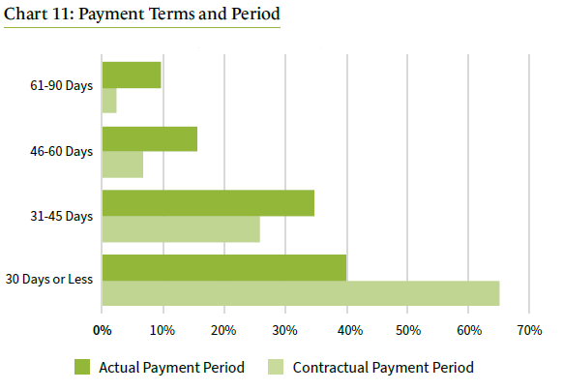
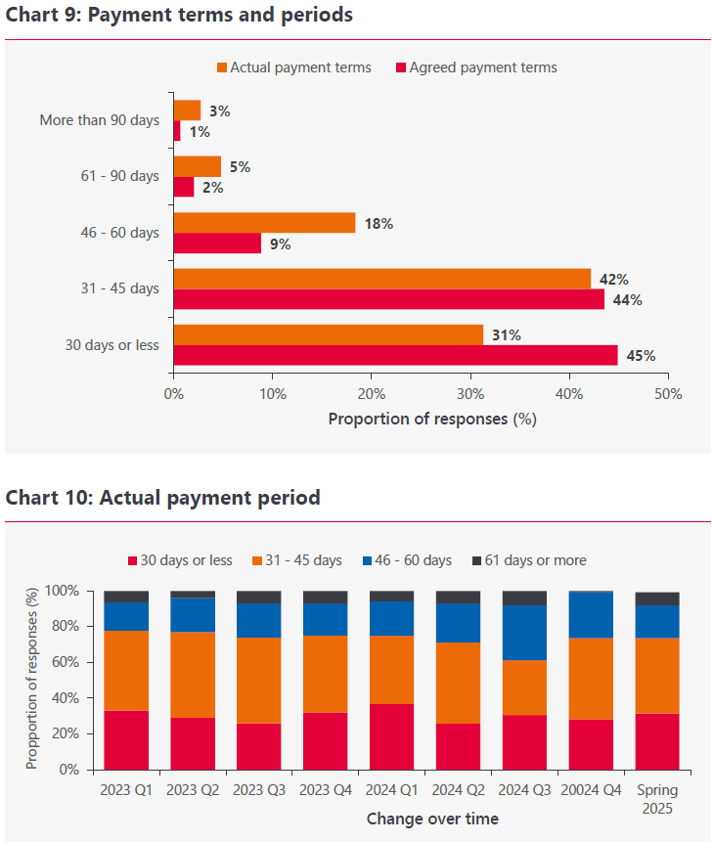
NFRC’s own research similarly shows that while only around 4% of our Members regularly agree to terms over 60 days, nearly 8% of payments are ultimately made later than 60 days. Progress has stalled in recent years, with actual payment terms remaining static since 2020 despite greater reporting requirements.
NFRC State of the Industry Report Spring 2025
NFRC State of the Industry Report Q4 2020 – Note: earlier surveys did not record payment periods over 90 days, so results for 61–90 days in previous reports have been compared with the combined 61–90 day and over 90 day categories in current data.
NFRC’s State of the Industry Report Spring 2025 shows that payment practices have barely improved since we began tracking them in late 2020. Back then, 9% of NFRC Members reported waiting more than 60 days for payment; in 2025, the figure is still 8%. This stubborn consistency, hovering just below 10% during most quarter over the past five years, demonstrates that existing rules have failed to stop the worst offenders. To tackle late payment, the option to pay beyond 60 days must be removed entirely.

Q10c. Are there any potential unintended consequences or considerations that should be taken into account for the introduction of this measure?

Yes

Q10d. Please explain the reasons for your answer to question 10c.

While removing the option to extend payment terms beyond 60 days is a positive step, NFRC Members warn that 60 days remains too long, especially if other reforms, such as changes to retentions or stricter enforcement of late-payment interest, prompt some firms to recoup lost cash flow by stretching terms to the full 60 days. This risks undoing recent progress, reversing the trend toward faster payments that now typically more regularly arrive closer to 30 days.

To prevent this backsliding, NFRC urges government to reduce the maximum payment term to 45 days within this measure, with the goal of reducing to 30 days in five years.

In reality, a “60-day” term often means businesses wait over three months to receive payment. This delay forces firms to rely on costly credit, driving up project costs and exposing both companies and individuals to greater financial risk. The impact is far-reaching:
- Higher risk of insolvency and bad debt
- Weaker cash flow and reduced project resilience
- Limited capacity for growth, training, and innovation
- Added administrative and financing costs
- Financial and emotional strain throughout the supply chain

As one NFRC Member puts it: “We pay staff weekly and suppliers on 30 days. 60 day payments would restrict cash flow to dangerously low levels. If the main contractors have the option of 60 days they will use this.”

Q10e. What exemptions, if any, do you think should apply and why – for example, in specific sectors or in particular circumstances?
There are no sectors or circumstances within construction where exemptions are justified. Even on critical infrastructure projects where companies do not pay by monthly instalments, there is no need for special treatment. The 60-day countdown starts from the date the payment application is submitted, not from when the work itself is completed, meaning quarterly payments or other agreed schedules are still possible, but the payment deadline is clear, allowing for stability in forward thinking.

This measure would still allow for quarterly or other interval progress payments and so there should be no exemptions as they just create loopholes allowing parties to circumvent the law. Exemptions open the door to loopholes for clients to delay payment by hiding behind complicated legal wording, perpetuating the problem. A foundational aspect of any legitimate business or organisation must be its ability to pay its suppliers within a reasonable time frame.

Q11a. To what extent do you agree that introducing a 30-day time limit on the ability for businesses to dispute invoices will be effective in addressing the stated problem of the deliberate disputing of invoices to extend payment times?

Strongly agree

Q11b. Please explain the reasons for your answer to 11a

Within the construction sector, the Housing Grants, Construction and Regeneration Act 1996 (Construction Act) sets out the framework for payment processes, including when payments are due, when notices can be issued, and when final payment must be made.

Because of Construction Industry Scheme (CIS) tax rules and the VAT domestic reverse charge, construction businesses generally submit an application for payment before issuing a formal invoice that reflects the agreed payment amount. Statutory guidance on payment reporting regulations clarifies that, in construction, references to “invoices” in general payment law should be interpreted as applications for payment, the point at which the client first becomes aware of the sum owed. The payer then has two opportunities to dispute the amount before the final payment date, but they must ultimately pay the figure confirmed in their last notice.

While the law restricts how and when a client may dispute payments, it does not restrict how long the overall payment process can take. This loophole allows some clients to exploit extended timescales. If no specific timetable is agreed, the legal default is 17 days, but in practice, payment periods are often stretched far beyond this, sometimes up to 120 days or more, depending on what clients believe they can impose. Such delays are grossly unfair, wasting time, increasing financial risk, and undermining the ability of UK construction SMEs to support the government’s ambitions on housing, retrofit, and infrastructure delivery.

For these reasons, introducing a statutory 30-day limit on the process for disputing applications under the Housing Grants, Construction and Regeneration Act is both fair and essential.

Q11c. Are there any potential unintended consequences or considerations that should be taken into account for the introduction of this measure?

Yes

Q11d. Please explain the reasons for your answer to question 11c.
Some NFRC Members have expressed concerns that the 30 day limit will become a target, with frivolous disputing targeted towards day 29. This must be countered by adequate monitoring of, and punishment for, repeated instances of unsubstantiated disputation.

Q11e. Are there more effective ways the Government could prevent frivolous disputing of invoices?
A combination of:
- a 45-day maximum on all payments,
- mandatory interest on late payment at a sufficiently punitive rate,
- accounting for interest on late payments,
- fining businesses who repeatedly pay late,
- a long-stop period to dispute invoices.

These measures would go some way to preventing the exploitation of payment systems which currently disadvantages specialist construction businesses.

Q12a. To what extent do you agree that all qualifying contracts being subject to mandatory statutory interest on their late payments without exception will address the stated problem and help incentivise paying on time?

Strongly agree

Q12b. Please explain the reasons for your answer to question 12a

Currently, during the contract negotiation period within construction, some clients regularly lower or remove the right to claim statutory interest on late payments. SME contractors often feel obliged to accept these terms for fear of losing work, or they are otherwise overwhelmed by other excessive changes to standard form contracts to notice and understand the change. The ability to remove the statutory requirement makes it effectively meaningless. Removing the ability of negotiating parties to vaguely agree ‘some other substantial remedy’ to the rate of statutory interest set by the Secretary of State would help ensure there are meaningful consequences to late payment.

This proposal would bring the UK in line with other EU trading environments where the step has successfully been taken and safeguards economic resilience. For too long, clients and large contractors within construction have been incentivised to sit on late payment for interest gains, capital, and liquidity, passing risk through their supply chain to smaller companies. Mandating statutory interest will help change that.

A small claims type process to secure interest payments where it has not been added should be easy to access with upheld claims reportable through accessible mechanisms set down and fines imposed.

Q12c. Are there any potential unintended consequences or considerations that should be taken into account for the introduction of this measure?

No

Q12d. Please explain the reasons for your answer to question 12c.

N/A

Q13a. To what extent do you agree that requiring businesses that report under the Reporting on Payment Practices and Performance Regulations 2017 to report how much interest they owe and pay to their suppliers as a result of late payments will help incentivise reporting businesses to improve their payment practices?

Strongly agree

Q13b. Please explain the reasons for your answer to question 13a

Reporting brings essential transparency for improving payment performance. Without transparent reporting or enforcement on interest owed, businesses can and will negotiate settlements which do not include proportionate interest payments. Legislating the need to pay interest on late payments is not a strong enough deterrent to change commercial behaviour, unless the consequences of non-compliance are clear and enforced, or payment performance is transparent and must be accounted for.

If businesses were able to see information about how much interest a firm owes, as well as how much they pay to their suppliers because of late payment, they would be able to make educated decisions about who they can afford to work with. Interest owed and interest paid should be shown as a percentage of the total interest owed so that the supply chain can reliably monitor and compare performance amongst large businesses. The gathering of such data would also allow for accurate analysis at a macro level of the progress of interventions to stop late payment.

Q13c. Are there any potential unintended consequences or considerations that should be taken into account for the introduction of this measure?

No

Q13d. Please explain the reasons for your answer to question 13c.

With the widespread adoption of digital platforms that automate payment processes and reporting, including functionality to track and report interest owed, there would be no significant cost to implementing more robust reporting requirements. Any associated costs would be far outweighed by the benefits to the wider supply chain.

Q14a. To what extent do you agree that introducing financial penalties for large businesses persistently paying their suppliers late will address the stated issue and incentivise reporting businesses to pay on time?

Strongly agree

Q14b. Please explain the reasons for your answer to question 14a

Companies that unjustly withhold payment reap benefits in the form of interest, capital, and liquidity, costing the UK economy £11 billion a year and closing 38 businesses a day. It is essential there are consequences for this destructive behaviour. Fines and fee-for-fault models are already used in the UK with competition, data privacy and health & safety law to ensure the system is self-sustaining and cost neutral as an enforcement system. Similar models can be extended into the payment sphere.

It is important to ensure that, despite restricted powers with respect to construction, the Small Business
Commissioner has the right to impose fines on construction companies.

Q14c. Are there any potential unintended consequences or considerations that should be taken into account for the introduction of this measure?

No

Q14d. Please explain the reasons for your answer to question 14c.

N/A

Q14e. To what extent do you agree that linking financial penalties for consistently late- paying businesses to their unpaid statutory interest liabilities is a proportionate and effective approach?

Strongly agree

Q14f. Please explain the reasons for your answer to question 14e.

Current solutions which rely on the payee to spend money challenging the payer to recover monies owed are fundamentally unequal. Time and resource limitations often lead to smaller businesses writing off owed money due to an inability to pursue justice, which is prohibitive to driving cultural change across the construction sector. Larger companies routinely take advantage of this unequal arrangement and avoid consequences. Automatically tying financial penalties to transparent and accurate unpaid statutory interest liabilities would incentivise positive change by increasing visibility on the solvency risk of paying companies and the exposure to fines will go some way to deterring them from engaging in negative payment behaviour.

Over time, depending on the efficacy of this measure, it may also become worthwhile to introduce triggers associated or tied to:
- Average days to pay by volume and value
- % invoices paid within terms by volume and value
- Unpaid statutory interest liability
The measuring of these variables should similarly be viable through financial technology platforms and their use would further increase transparency and encourage good behaviour.

Q15a. To what extent do you agree that the introduction of the new powers for the Small Business Commissioner will be effective in improving compliance and enforcement of new and existing regulations around payments?

Strongly agree

Q15b. Please explain the reasons for your answer to question 15a

The Small Business Commissioner (SBC) currently has its jurisdiction and powers limited by the lack of investigative and enforcement abilities and insufficient resourcing. The Fair Payment Code, while positive from a rhetoric perspective, has no teeth and little sway when it comes to procurement, and as a result is poorly subscribed. The proposed improvements would help to unlock the SBC’s potential. However, the SBC continues to lack jurisdiction over construction which we see as unfortunate for our sector.

Q15c. To what extent do you agree that the introduction of the new powers for the Small Business Commissioner will enhance its ability to support small businesses to resolve payment disputes?

Strongly agree

Q15d. Please explain the reasons for your answer to question 15c

As it stands, the Small Business Commissioner does not have the scope and enforcement powers to significantly improve the experiences of SMEs across the UK.

Q15e. Are there any potential unintended consequences or considerations that should be taken into account for the introduction of this measure?

No

Q15f. Please explain the reasons for your answer to question Q15e.

We have concerns that there is no intention to extend the SBC’s powers to encompass construction, potentially leaving construction without the same protections as other parts of the economy. Within construction, the process and cost of adjudication have grown beyond being effectively usable for most disputes for SMEs and over not insignificant amounts of money. Costs are disproportionately high
for low-value claims, discouraging or preventing smaller firms from pursuing adjudication for what are still significantly high losses relative to their business size.

Q16a. To what extent do you agree that the requirement for businesses to report under the Payment Practices and Performance Reporting Regulations should be changed from twice a year to once a year?

Strongly disagree

Q16b. Please explain the reasons for your answer to question 16a

Once a year would risk data being 11 months out of date, harming the ability of businesses to make educated decisions about who they work with. As the data mainly involves aggregated averages and percentages, a reduction in regularity would make the data 50% less reliable. To maintain credibility the reports must be kept as 6 monthly. If reporting is reduced to once a year the reports would risk becoming redundant.

Q17a. To what extent do you agree that prohibiting the use of retention clauses in construction contracts would be effective in addressing the stated problems associated with retention?

Strongly Agree

Q17b. Please explain the reasons for your answer to question 17a.

Banning abusive retention clauses is essential to unlocking growth for roofing and cladding businesses and the wider construction sector. Currently, payees must fight to prove payment is due, while payers hold the money, earn interest, and often delay or deny release. Many firms give up chasing retentions they are rightfully due, costing time, money, and wellbeing.

In 2021, we surveyed Members and estimated that £300 million of roofing and cladding subcontractors’ cash was held in retention at any one time. In 2023, 86% of Members surveyed reported difficulties recovering retention payments on local authority contracts.

Retentions risk being lost entirely if a company collapses. In 2017, according to the BEIS Research Paper 17 by Pye Tait (2017), around £6 billion is tied up in retentions at any one time, with over £229 million lost to insolvency each year, and these figures will only have grown. Carillion and ISG demonstrate what happens at the worst end of this, but smaller disasters also happen regularly. Retentions are a key issue keeping construction the UK’s most insolvent sector. One NFRC member, who lost £127,000 in owed retentions to ISG’s collapse, asked, “How has the supply chain been let down so badly?”

According to the same paper, 37% of tier 1 contractors use retentions for working capital, 29% use it for general expenditure and 11% use it to fund the project the retention is from. Nothing prevents holders using the money for their own purposes. On average, £27,500 worth of retention monies is outstanding per contractor, a significant amount, especially for smaller firms.

Even without insolvency, abuse of retentions is rife. In 2025, 80% of responding NFRC contractor Members reported that retentions affect their business, with 19% reporting a significant impact, 36% a moderate impact, and 25% a minor impact.

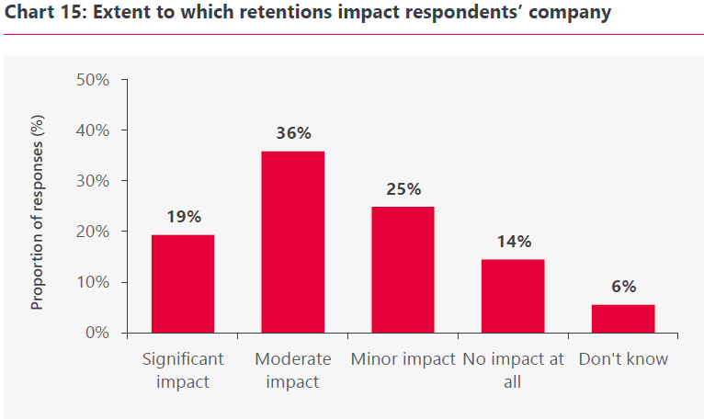
NFRC State of the Industry Report Spring 2025

We are regularly approached by Member businesses with stories of retention abuse by larger contractors and developers.

One Member told us, “Developers like to hold money on us so that they are the ones in the driving seat, and usually if there are any disputes we end up having to therefore concede, just in order to get paid (i.e. it’s ‘needs must’)… and developers will sometimes go beyond, and in fact abuse the privilege altogether.”

Within roofing and cladding, other forms of surety, including manufacturer and workmanship-backed guarantees, outperform retentions in protecting clients without the opportunity for abuse, with defect liability periods commonly ranging from 5-30 years, far exceeding the standard two-year defect liability period of retention clauses. However, clients continue to impose and delay payment of retentions where they can, because of the capital and cash flow it provides them and the lack of consequences.

Abolition is the tidiest and most surefire way of ensuring this behaviour is stamped out. Legislation to ban retentions must be airtight to prevent alternative methods of delaying payments arising. Amending the Construction Act 1996 to explicitly prohibit the use of cash retention clauses in any construction contract would be the beginning. The proposed Construction (Retentions Abolition) Bill should insert a section declaring that any contract term “which enables a payer to withhold retention monies” is invalid and of no effect. The law would also need to provide a sufficiently broad definition of retention, not just by name, but by function. This could take the form of “any arrangement where a sum due to a contractor is withheld beyond the due date or completion as security for performance or defects”. An anti-avoidance clause could also make clear that any contractual scheme or device designed to circumvent the ban is also void. This could mirror language used in other legislation (e.g. anti-avoidance in insurance or tax law) to catch “substantially similar” practices.

To back up the ban, the legislation could empower sanctions. For example, if an organisation is found to be flouting the rules (say, by a side agreement to hold money in escrow unofficially), the subcontractor could have an immediate right to recover that money plus costs. While criminal penalties (as seen in New Zealand’s regime) might be out of the norm for UK contract law, administrative fines or loss of public-sector eligibility could be considered for wilful violators.

If bonds are required, or current performance bonds are adapted to extend into the defects periods becoming a hybrid of performance and retention bonds, the cost should be covered by the payer rather than the payee. SMEs are typically too small to be a viable risk for bondsman/insurers.

It is worth noting here that a small proportion of NFRC Members, typically medium or larger businesses, favour protection of retention funds as opposed to outright abolition. These businesses use retention against their own subcontractors, and feel it to be a worthwhile means of ensuring defect rectification. We have supported these Members to make their own responses to this consultation identifying their preference for protection. They also recognise the problems inherent within the current regime and would like to see reform regardless. NFRC’s overall position, representing the majority of our Members, is that abolition is the most effective way of ensuring the problems associated with retentions are addressed.

Q18. Under a prohibition on the use of retention clauses in construction contracts, what alternative measures would a payer seek to ensure performance and quality from a supplier? Please explain the reasons for your answer.

Ensuring quality is essential, but retentions are no longer fit for this purpose, and superior alternatives are already in widespread use throughout the roofing and cladding industry and have been for a long time. Manufacturer and workmanship-backed guarantees outperform retentions in protecting clients, with defect liability periods commonly ranging from 5-30 years, far exceeding the standard two-year defect liability period of retention clauses. Additionally, robust accreditation and investment in operative training, which is often restricted by cash flow issues caused by unjustly withheld retentions, go much further towards preventing defects in the first place. Legislative reform could strengthen defect liability remedies other than retentions by mandating that construction contracts explicitly include a defects rectification clause.

There must also be an increased focus on strong pre-qualification and supply chain management, strategic pipeline/framework purchasing relationships and early supply chain involvement. If businesses are financially robust, a good specification is in place, good quality control exists, adequate other protections such as workmanship guarantees are in place, and the overall approach is collaborative, there is no need for cash retention. It is worth noting that these measures are also critical for the drive towards safety and accountability that government is focusing on post-Grenfell and should be happening at pace regardless. For too long, cash retention has driven a lowest price approach and, over the long term, driven sub-optimal margins and compromised the quality and safety of the UK’s built environment.

Moreover, the Security of Payment regime remains available, meaning that if a client finds defects, they can still issue a Pay Less Notice for the value of defects before the final payment. What must be banned is the blanket pre-emptive withholding that inherently occurs with retention clauses.

Q19. What length of transitional period would be required for a payer to adjust to the ban measure? Please explain the reasons for your answer.

With projects averaging 18 months, no more than 24 months should be allowed for industry to transition and ensure business models can cope. Ideally, this would be a shorter process of 12 months with new contracts after a certain date, for example the start of a financial year, prohibiting the use of retentions. Corrections to standard form contracts should be relatively simple. It should be noted that a number of our Members have implemented a no retentions policy on their contract submissions with some success. This did not require a transitional period.

Q20. Please provide an estimate and an explanation of any costs firms would incur as the result of prohibiting the use of retention clauses in construction contracts.

Some payers may incur indirect costs in the short term when they lose access to payee’s retention monies as free finance/working capital that they can call on for their own operations. However, this should not be considered a loss, as such profitability was gained at the expense of the productivity and stability of the wider construction industry, and especially at the cost of those on the delivery end of projects such as specialist subcontractors who suffer most from retentions. Accounting for the measure will require some businesses to adjust their business models so that they do not rely on retention funds as freely available working capital.

Any purported losses in productivity at the top by these large firms would be more than compensated for by payee cost savings and productivity gains as SME businesses would no longer incur the significant overheads and costs of chasing retentions.

Q21a. To what extent do you agree that requirements to protect retention sums deducted and withheld under retention clauses in construction contracts would be effective in addressing the stated problems associated with retention?

Somewhat disagree

Q21b. Please explain the reasons for your answer to question 21a.

Clients will naturally seek security against the risks of supplier insolvency and failure to remediate defects, however, within roofing and cladding, there are already far more effective ways to protect against supplier insolvency and defective work than retentions. Workmanship guarantees and manufacturer warranties, alongside insurance backed-guarantees in the event of contractor insolvency, are already widely used by accredited, reputable firms. These protections exceed the standard two-year defect liability period linked to retentions and offer clients far greater assurance. If contracts were awarded only to businesses meeting these standards, such protections would apply across all roofing and cladding works. Additionally, the move towards third party certification requirements in procurement to prove organisational and individual competency across construction activities is at odds with the original purpose of retentions within the construction industry. While measures such as project bank accounts or other forms of surety might mitigate some of the risks associated with retentions, the practice would continue to slow down cash flow and undermine the ability of businesses to grow at the pace needed to meet government new build housing, retrofit, and infrastructure targets.

However, if abolition is deemed not possible, for whatever reason, reform to the current regime remains essential and, in this instance, NFRC would support policy to protect retention sums withheld under retention clauses in construction contracts. If executed correctly, and with appropriate oversight from all parties through the supply chain, these funds would ideally be safeguarded from misuse and insolvency. For retention in trust to be truly impactful, changes to regulation would have to ensure retentions are automatically released at the defined date alongside all accrued interest. Release cannot require additional applications from contractors or relate to dates that are not explicitly connected to the completion of their works.

It is worth noting that introducing protection requirements and regular reporting against held retentions introduces additional workload and paperwork for companies to report against retentions held which will take time to bed in.

Q22a. What would be the preferred mechanism of a payer to protect the retention sums?

Workmanship guarantees, manufacturer warranties, and insurance-backed guarantees, which are already in wide use by reliable and accredited roofing and cladding contractors and NFRC Members, provide stronger protection for both clients and contractors than retentions, even when those retentions are secured. However, if protection is mandated, the best mechanism would likely be protection via a trust account for sums over a certain de-minimis value under which retentions are abolished.

Q22b. Please explain the reasons for your answer to question 22a.

The roofing and cladding industry already has sufficient protections in place to ensure the quality of works and the protection of clients, as outlined previously, making abolition preferable, and protection unnecessary.

It is worth noting that, were protection to be mandated, payers are likely to push for the ability to co-mingle retention sums with their own working capital, while having retention sums separable in the event of insolvency. However, from a payees perspective, it would be much more fair to have the retention sums placed in a protected trust account and automatically identified as belonging to the payee from the outset.

Q23. What length of transitional period would be required for a payer to adjust to the retention protection measure? Please explain the reasons for your answer.

With projects averaging 18 months, no more than 24 months should be allowed for industry to transition and ensure business models can cope. Ideally, this would be a shorter process of 12 months with new contracts after a certain date, for example the start of a financial year, prohibiting the use of retentions. Corrections to standard form contracts should be relatively simple.

Q24a. To what extent do you agree with the proposed features of the retention protection measure?

Somewhat disagree

Q24b. Please explain the reasons for your answer to question 24a, including any further features to the design and operation of this retention protection measure that you would recommend.

Abolition would be a preferable and more effective option than protection. However, if protection measures were implemented, taking retentions from the final payment only would simplify the administration greatly. Consideration should be given to a reasonable cap.

Q25. Please provide an estimate and an explanation of any costs firms would incur as the result of the introduction of a framework for protecting retention sums.

The fees associated with holding a bond would further erode the already narrow margins of specialist construction firms. However, if abolition is not deemed possible and protection is deemed necessary, if costs can be brought down to well within the interest rates that the accounts generate, this could provide an acceptable alternative. Controls would have to be implemented to ensure that the level of fees are controlled and not disproportionate to the level of service provided.

Q26. Are there any potential unintended consequences or considerations that should be taken into account for the introduction of either proposed measure for the use of retention clauses in construction contracts? Please explain the reasons for your answer.

Protecting retention monies risks diverting funds to the lawyers and banks that would administer them, at the expense of the already struggling businesses least able to bear the cost. The tightly managed abolition of retention clauses, with measures to ensure they do not arise under another name, is the most straightforward way of eliminating this harmful practice from the construction sector. If protection was to be used, controls would have to be implemented to ensure that the level of fees are controlled and not disproportionate to the level of service provided.

Q27. Do you have any further comments on either proposed measure for the use of retention clauses in construction contracts?

Abolition is the more effective option for the roofing and cladding industry. Without reform of harmful retention practices, the construction sector’s potential to deliver on the Government’s key priorities of housing, skills, growth, infrastructure, and net-zero will be compromised.

Q28. Do you have any further comments on any elements of the proposals that might aid the consultation process as a whole?

Improving the accessibility and usability of payment practice data is an additional clear area for progress. Currently, SMEs struggle to interpret information that is fragmented across multiple platforms. A centralised, user-friendly portal, for reviewing reported payment practices, actively promoted to businesses, would greatly enhance transparency and accountability across the supply chain.

A further issue repeatedly raised by NFRC Members is the rise of early payment rebate schemes. These arrangements, where suppliers accept discounted payment for works in exchange for payment within, for example, 15 days rather than 30, have proliferated in both the public and private sectors as a short-term response to chronic cash flow pressures caused by late payment. While it is understandable that some businesses would seek such arrangements to ease cash flow, our Members are clear: they do not want to be paid early, they want to be paid on time.

Many Members also report feeling pressured to participate in rebate schemes as a condition of securing contracts, particularly with local authorities where the practice is becoming increasingly common. The intermediaries facilitating these schemes further strain an already fragile payment ecosystem by taking an additional margin from suppliers’ earnings, often up to 1.5%.

NFRC hopes that the measures proposed in this consultation, if implemented effectively, will reduce the need for such costly and distortive arrangements. However, the growing prevalence of early payment rebates should remain under active review by the Department for Business and Trade’s fair payment division.

We welcome the Government’s Small Business Plan, its recent Late Payment Research, and this accompanying consultation. However, for Government to truly deliver on its wider missions, particularly those relating to the built environment and net zero, targeted interventions of the kind outlined in this consultation are essential. This process must lead to genuine reform, unlike previous reviews of retention clauses, which failed to materialise despite strong industry backing.

Among NFRC Members, there is already a strong sense of disillusionment with the Government’s willingness to address these long-standing issues. NFRC therefore hopes that both our response and those of our Members will not be in vain, but instead help drive meaningful change.

