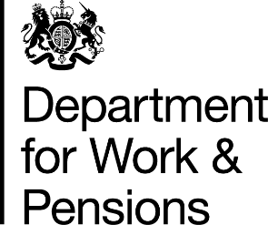
1 September 2025

Good afternoon,

Department for Work and Pensions – Work Experience Opportunities
I hope this message finds you well. As a valued partner of the Department for Work and Pensions (DWP), I am contacting you to share some exciting news about our ongoing efforts to boost the economy and provide unparalleled support for employers like you.
As part of our new Employer Engagement Strategy, we are committed to becoming your Recruiter of choice by recognising the economic challenges, varying labour markets, and the specific supply and demand needs your sector may face.
To facilitate this, we are holding an online Webinar to delve deeper into how the features and benefits of the Department for Work and Pensions employer products can support you achieve your recruitment aims.
One of the employer products that we are spotlighting is Work Experience. On the webinar we will be joined by large national employers who will speak about their Work Experience programme, how it operates and the benefits that it has brought to their business.
Webinar Details
The webinar will be held on18 September 2025
Time: 2pm to 3pm
How to book: To book your place Please click on the Eventbrite link below - https://www.eventbrite.co.uk/e/dwp-work-experience-webinar-tickets-1630829798829?aff=oddtdtcreator

If you are unable to join the webinar and would prefer a more personalised setting, please respond to this e-mail and your DWP Recruitment Manager will be in contact with you to arrange a meeting.

Thank you for considering this opportunity. We look forward to collaborating with you and supporting your recruitment needs.

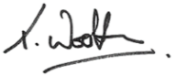
Theresa Wootten
Head of Recruitment and Sales
Strategic Relationship Team

