**NFRC YNE Regional Members event – 19th JUNE 2025**

**Thimbleby Shooting Ground**

**Thimbleby Estate (just off the A19)**

**Northallerton, North Yorkshire**



Set within Thimbleby Estate and surrounded by thousands of acres of stunning countryside, Thimbleby Shooting ground lies in an idyllic rural setting within the North Yorkshire Moors National Park

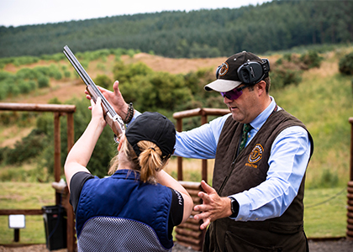

This is your chance to experience the excitement of clay pigeon shooting, whether a beginner or an experience shooter. This event is open to NFRC members and their guests and is set in the Thimbleby Estate, North Yorkshire.

The day will kick off at 10.00am with a bacon roll and a cuppa and a chance to network and meet the NFRC team. We will be having a hot buffet lunch followed by an afternoon of shooting, all winding up about 4.00pm The usual cost of this day would be £100.00 but as a member of the NFRC we are only charging **£40.00 plus Vat** (less than half price)

When shooting you will have an instructor at hand to help and advise if required, and the day is open to all genders. If fact the female of the species tend to shoot very well, not sure what they are thinking when they pull the trigger!

So come along and have a great day out, treat your staff or customers. If you wish to attend please complete the booking this form and return it to me, I will raise an invoice as proof of your place.

**Company Name -**

**Company Address -**

**Please book ……. places on the NFRC Clay Pigeon Shooting Day at £40.00 plus VAT pp**

**Name of person booking the event & email address**

**Please note; Non shooters can attend the full day including the meal at a cost of £25.00 plus VAT**

Please return booking form to Martin Adwick – YNE Regional Manager

[martinadwick@nfrc.co.uk](mailto:martinadwick@nfrc.co.uk)