The scheme

The National Heritage Roofing Contractors Register scheme identifies, assesses and accredits companies and individuals that have the required skills, knowledge and experience in the historic and vernacular systems of clay tile, slate, stone, shingle or metal roofing in the UK. The scheme is open to all roofing companies with the appropriate skills knowledge and training in heritage roofing.

Benefits of joining the National Heritage Roofing Contractors Register

The Heritage Register is officially recognised by all relevant heritage and training organisations:

- ​Historic England
- Cadw Welsh Historic Monuments
- The Environment and Heritage Service for Northern Ireland
- Historic Environment Scotland
- The National Heritage Training Group
- The Construction Industry Training Board

Their endorsement, along with our robust vetting and inspection regime, gives clients and specifiers confidence that they’re hiring someone with the precise skills that heritage roofing work requires.

The Heritage Register is listed on NFRC website and gives those registered access to opportunities for heritage work. Being on the register represents the ‘quality stamp’ that clients and specifiers are looking for.

Successful applicants will have use of the National Heritage Roofing Contractors Register logo to use on their website, emails or other marketing materials.

Costs

NFRC Member | Free, however an on-site assessment fee of £295 plus VAT may be applicable if the application committee deems that a site inspection is required
Non NFRC Member | £395 plus VAT, to cover costs for registration and an on-site assessment

Classifications

Applicants can apply for one of three classifications, outlined below:

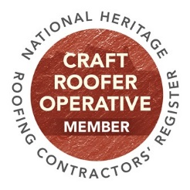 | Heritage craft roofer operative: This person will have experience in Slating and Tiling and the specific techniques of the nominated heritage roof type.  We will be looking for at least three examples of works that have been carried out on a pre-1919 property, using the original roof covering type, to original detailing, following the specification given.  For a successful application we would be looking carefully at roof detailing, such as, but not limited to, hips, valleys, ridges, abutments with walls and chimneys and would need to know the type of mortar used.  The prospective Craft Roofer Operative will provide high-resolution digital photographs of the roof, with particular attention paid to the details mentioned above.
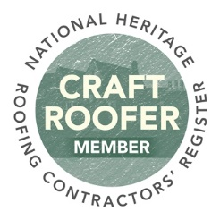 | Heritage craft roofer: A person applying for the position of a Heritage Craft Roofer must be capable of taking responsibility for workmanship on a heritage roofing contract and who will supervise the execution of the specification and working instructions formulated by a contract professional.  This person will have experience in Slating & Tiling and the specific techniques of the nominated heritage roof type. They will also understand the principles of roof conservation.  For a successful application we will be looking for at least three examples of works that have been carried out on a pre-1919 property, using the original roof covering type, to original detailing, following the specification produced by the architect or surveyor.  We would be looking carefully at roof detailing, such as, but not limited to, hips, valleys, ridges, abutments with walls and chimneys and would need to know the type of mortar used.  The prospective Heritage Craft Roofer will provide high-resolution digital photographs of the roof, with particular attention paid to the details mentioned above.  The prospective Heritage Craft Roofer should be able to identify details in specifications that are not correct, not matching the likely original detailing, and be able to discuss this with the specifier.

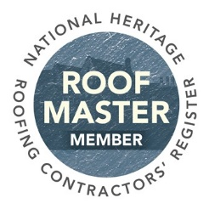 | Heritage Roof Master: Must be capable of taking responsibility for the design and performance of the roof, and of adequate experience to meet the following criteria:  This person will have an understanding of design, historic and vernacular authenticity, together with technical issues such as insulation, ventilation and condensation, through to the complications of various types of materials and their fixings, roof pitches and lapping systems and the responsibility for working instructions issued to the leading craftsman. This person will be able to work closely with the architect and historian to achieve a satisfactory specification for the heritage roofing contract works.  A Heritage Roof Master will have experience in Slating and Tiling and the specific techniques of the nominated heritage roof type. They will also understand the principles of roof conservation.  For a successful application we will be looking for at least three examples of works that have been specified by the applicant, in keeping with traditional methods, using traditional materials, that are a re-creation of the original coverings, dating back to the time at which the building was erected. This will always be on a pre-1919 property.  We would be looking carefully at roof detailing, such as, but not limited to, hips, valleys, ridges, abutments with walls and chimneys and would need to know the type of mortar used. Any variations from the true original would need to be fully explained.  Full specifications will need to be provided for each project to be considered.  The applicant should be able to demonstrate that the final works carried out by their employees has been carried out to the highest standard, fully to the specification produced by the prospective Roof Master.  The prospective Roof Master will provide high-resolution digital photographs of the roof, with particular attention paid to the details mentioned above.  The prospective Roof Master would, ideally, be able to demonstrate that he or she has been able to lead a client, architect, surveyor, or the like, into changing an existing, incorrect detail, such as from a later repair or re-roof, back to the detail that would have been used originally.

How to join

Please complete the application form and include your portfolio of evidence including detailed photographs of work before, during and after construction, and evidence of the skills, knowledge and training. The photographs must be a high-resolution of a 300dpi minimum. The evidence you submit must support the classification and roofing type(s) you are applying for.

Once we have received your application it will be passed to the Heritage Technical Committee for their review and if required an on-site assessment can be arranged.

Return completed application form and supporting evidence to Jo Lear: NFRC, Roofing House, 31 Worship, Street, London EC2A 2DY or email joannelear@nfrc.co.uk.
For further information call 020 7638 7663.

