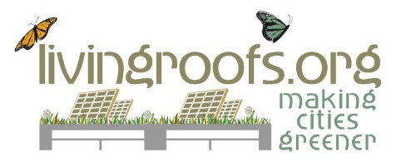
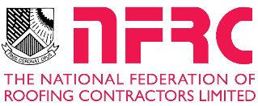
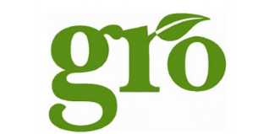

PRESS RELEASE PRESS RELEASE PRESS RELEASE PRESS RELEASE PRESS RELEASE PRESS RELEASE PRESS RELEASE

24th July 2017 FOR RELEASE 26TH JULY 2017

Publication Launch
The UK Green Roof Market - First Assessment
8.30 am – 10.00 am Wednesday 26th July 2017
London’s Living Room, London City Hall Potters Fields SE1 2AA

Today, the First Assessment of the UK Green Roof Market is launched at London City Hall at an event hosted by the Deputy Mayor for Environment and Energy, Shirley Rodrigues.

Our cities face urgent challenges in the 21st Century. The impacts of climate change are increasingly being felt – heatwaves, storms and flooding, air pollution and more.

Green roofs are an essential tool in combatting climate impacts in cities while providing much-needed space for nature.

The UK will need a healthy green roof market if it is to deliver the adaptation necessary for the health, well-being and prosperity of our towns and cities.

Today, for the first time, data is being published on the size, value and growth of the UK’s home-grown green roof market.

And the report shows something astonishing is happening – the UK green roof market is delivering an incredible 17% increase in growth year on year.

“Roofing is sometimes viewed in a narrow context,” says James Talman, CEO of the National Federation of Roofing Contractors.

“But the continued expansion of the green roof market plays an essential role in highlighting the diversity of the industry. Apart from the ecological, environmental and social benefits green roofs provide, they also are important in creating rewarding careers for multi-skilled professionals.

“We are pleased to support the green roof industry in its quest to see other large urban conurbations in the UK following the GLA’s lead on ‘greening’ our cities.”

The report demonstrates there is a green roof market focus in London, partly due to its specific planning policy.

The Deputy Mayor for Environment and Energy, Shirley Rodrigues says:

“In London our planning policies support green infrastructure which has led to an impressive array of green roofs that boost air quality, help the environment and make the city more attractive. From roofs that prevent flooding by capturing rainwater to providing wildlife habitats or high rise gardens, Londoners are using their space creatively. In the future to help mitigate the impacts of climate change and achieve the Mayor’s ambition of making the city 50 per cent green, we will need even more green roofs, green walls and street trees. I hope other cities follow our lead and realise the huge environmental benefits of urban greening.”

The report shows market growth of 17% year on year – both nationally and in London, where 42% of the market currently is focused.

But as the report also points out, there is huge potential to grow the market not just in London but in urban areas across the UK.

The growth of UK green roofs is helping to make the construction industry greener – and our cities healthier, more prosperous and resilient to climate impacts.

And it looks like it is going to continue to grow.

UK Green Roof Market Report Launch
PROGRAMME
8.30 Registration and refreshments
9.00 Shirley Rodgrigues London Deputy Mayor for Environment and Energy
James Talman CEO, National Federation of Roofing Contractors
Mark Harris Chair, Green Roof Organisation
Dusty Gedge Livingroofs.org
Kelly Bream Operations Director, Berkeley Homes
9.30 Networking
10.00 End

For more information contact
info@livingroofs.org

The UK Green Roof Market Report is produced by

Livingroofs.org

In association with

The National Federation of Roofing Contractors and the Green Roof Organisation GRO

Supported by

Radmat Ltd Bauder Ltd Sky Garden Ltd

www.radmat.com www.bauder.co.uk www.sky-garden.co.uk

